## **Lab 13: Android Alert**

# **Introduction**

For copying and pasting various kinds of data, including text strings, images, binary stream data, and other complex data types, Android's Clipboard framework is helpful. The simple text data is typically stored immediately in the clipboard by the android clipboard framework, while the complex data is typically stored as a reference that the pasting application resolves with a content provider. The clipboard copying and pasting functionality in Android is available both within and between apps that use the framework.

**Let’s get Started:**

This example shows how to use Kotlin to make a straightforward alert dialogue with OK and cancel options.

**Step 1:** open **activity_main.xml** file from **\res\layout** folder path and write the code like as shown below.

**activity_main.xml**

*<?*xml version="1.0" encoding="utf-8"*?>*<RelativeLayout xmlns:android="http://schemas.android.com/apk/res/android"  
 xmlns:tools="http://schemas.android.com/tools"  
 android:id="@+id/rl"  
 android:layout_width="match_parent"  
 android:layout_height="match_parent"  
 android:padding="8dp"  
 tools:context=".MainActivity">  
 <TextView  
 android:layout_width="wrap_content"  
 android:layout_height="wrap_content"  
 android:layout_centerHorizontal="true"  
 android:layout_marginTop="50dp"  
 android:padding="8dp"  
 android:text="Plural Sight Alert Demo"  
 android:textColor="#D32F2F"  
 android:textSize="30sp"  
 android:textStyle="bold" />  
 <TextView  
 android:id="@+id/button"  
 android:layout_width="match_parent"  
 android:layout_height="wrap_content"  
 android:layout_centerInParent="true"  
 android:clickable="true"  
 android:focusable="true"  
 android:text="Show Alert dialog"  
 android:textAlignment="center" />  
</RelativeLayout>

**Step 2:** Open main [activity](https://www.tutlane.com/tutorial/android/android-activity-lifecycle) file **MainActivity.kt** and write the code like as shown below.

**MainActivity.kt**

**package** com.example.demopluralsightalert  
  
**import** android.os.Bundle  
**import** android.support.v7.app.AlertDialog  
**import** android.support.v7.app.AppCompatActivity  
**import** android.widget.TextView  
**import** android.widget.Toast  
**class** MainActivity : AppCompatActivity() {  
 **private lateinit var textView**: TextView  
 **override fun** onCreate(savedInstanceState: Bundle?) {  
 **super**.onCreate(savedInstanceState)  
 setContentView(R.layout.*activity_main*)  
 *title* = **"DemoPluralsightAlert"  
 textView** = findViewById(R.id.*button*)  
 **textView**.setOnClickListener **{** showAlertDialog() **}** }  
 **private fun** showAlertDialog() {  
 **val** alertDialog: AlertDialog.Builder = AlertDialog.Builder(**this**@MainActivity)  
 alertDialog.setTitle(**"My Alert Dialog"**)  
 alertDialog.setMessage(**"Do you want to close this Dialog Box?"**)  
 alertDialog.setPositiveButton(  
 **"yes"** ) **{** _, _ **->** Toast.makeText(**this**@MainActivity, **"Thanks, Alert dialog Box closed."**, Toast.*LENGTH_LONG*).show()  
 **}** alertDialog.setNegativeButton(  
 **"No"** ) **{** _, _ **-> }  
 val** alert: AlertDialog = alertDialog.create()  
 alert.setCanceledOnTouchOutside(**false**)  
 alert.show()  
 }  
}

**Step 3: Check Output on Android Emulator and it should look like as given below.**

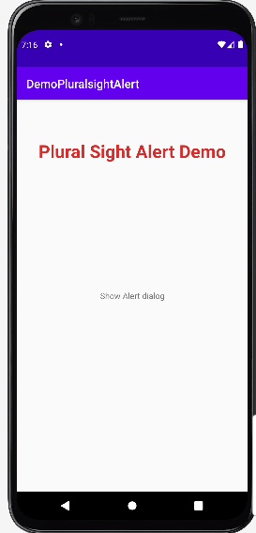 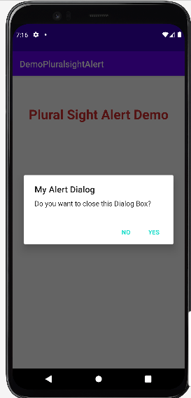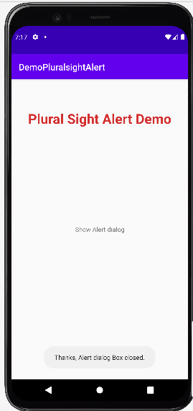

**Voila!!** We have successfully completed this lab.